**LIME LIGHT UNSTECH COLLECTION**

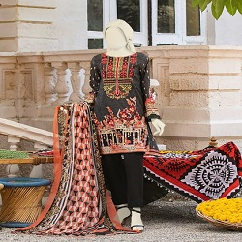

BASIC 3 PIECE:

Dupatta:3 Meters

Jacquard Shirt: 1.85Meters

Trouser: 1.8 Meters

**MORE INFORMATION:**

|  |  |
| --- | --- |
|  | |
| **Color** | Black |
| **Product Category** | Ladies 3 piece dress |
| **Volume** | Volume 9 2022 |
| **Collection** | Midsummer 22 |
| **Fabric** | Lawn |
| **Disclaimer** | Due to the photographic lighting & different screen calibrations, the colors of the original product may slightly vary from the picture |

**More colors** blue , pink , Bottal green